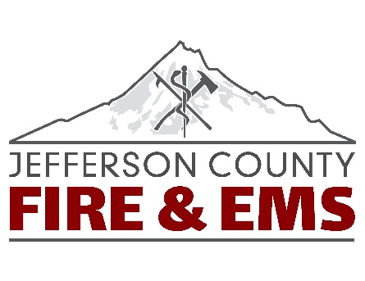
Jefferson County Fire & EMS
765 S 5th Street – PO Box 30
Madras OR 97741
Phone: 541.475.7274 Fax: 541.475.7411 www.jcfr1.org

Open Burning October 1st, 2023

Jefferson County Fire & EMS will open burning October 1st 2023. This will allow our patrons the opportunity to burn yard debris. If you would like to burn and have not yet attained a burn permit, you will need to go to Jefferson County Fire & EMS at 765 South Fifth St. Madras, OR. and get a permit. They are no cost. Business hours are Monday-Friday 8:00AM- 5:00PM. Please follow the guidelines below, do not burn on windy days, never leave your fire unattended, have a garden hose handy and make sure your fire is completely out at sunset. Weather conditions are still dry and windy, please be cautious when burning as fire will carry in fine fuels easily.

- Call before your burn! Once you have a permit, you will need to call the burn line and check if it is a burn day. 541-475-1789. Jefferson County Fire & EMS may close burning due to air quality, windy conditions, red flag warnings and for the fire season every year.

- Be mindful of inversion layers and check the air quality on the local DEQ website. https://oraqi.deq.state.or.us/home/map

- Follow Jefferson County Fire & EMS brochure on burning regulations and safe debris burning tips. If you need a copy of our brochure, stop by the station.

There are plans for two Fall Fire Free Events set for October 28th, October 29th and November 4th and 5th. This is another way to remove debris around your home. Please call 541-475-7274 if you have further questions.

